id | Priority | Question | A | B | C | D | Solution | Correct
9 | Low |  | 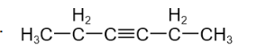 | 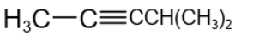 |  | 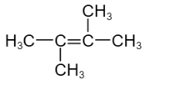 | 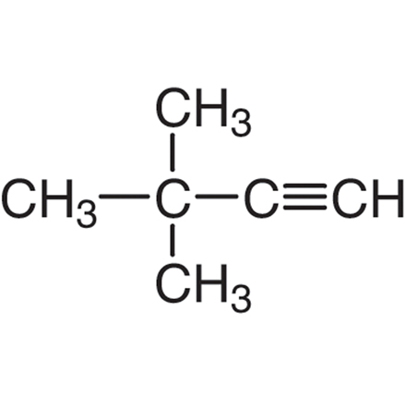 | a
9 | Medium | The focus of the parabola x²−8x+2y+7 = 0 is | (4, 4) | 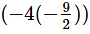 | 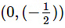 | 4, (9/2) | 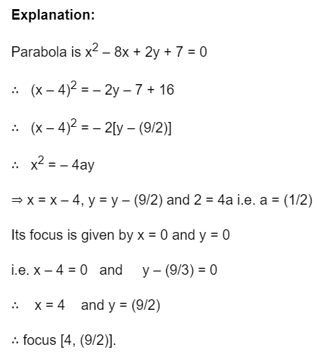 | d
9 | High | If the coefficients of (r +1)th term and (r + 3)th term in the expansion of (1+x)^{2n} be equal then | n + r – 1 = 0 | n = r – 1 | n = r + 1 | none of these. | 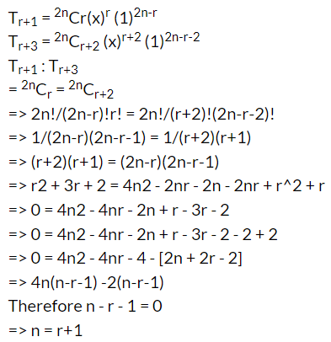 | c

